Task 6: (Syllabus Task 9) Develop a basic Spring MVC application using annotation based configuration. Create a controller to accept user requests and display employee
details using the MVC flow without XML configuration.

STEP 1: Create Maven Project
In Eclipse:
File → New → Maven Project
Add dependencies in pom.xml
<dependencies>
<dependency>
<groupId>org.springframework</groupId>
<artifactId>spring-webmvc</artifactId>
<version>5.3.30</version>
</dependency>
<dependency>
<groupId>javax.servlet</groupId>
<artifactId>javax.servlet-api</artifactId>
<version>4.0.1</version>
<scope>provided</scope>
</dependency>

<dependency>
<groupId>javax.servlet.jsp</groupId>
<artifactId>javax.servlet.jsp-api</artifactId>
<version>2.3.3</version>
<scope>provided</scope>
</dependency>
</dependencies>
Project Structure Image:
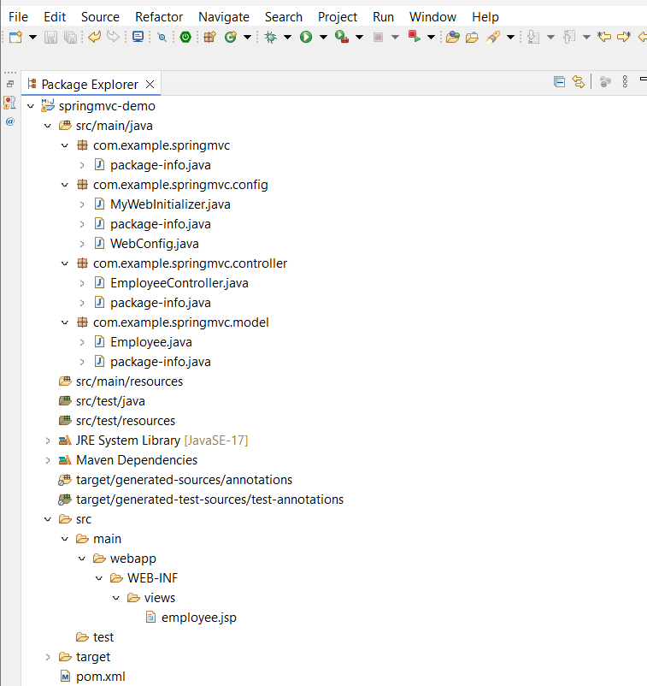

STEP 2: Model Class
Employee.java
package com.example.springmvc.model;
public class Employee {
private int id;
private String name;
private String department;
public Employee(int id, String name, String department) {
this.id = id;
this.name = name;
this.department = department;
}
public int getId() { return id; }
public String getName() { return name; }
public String getDepartment() { return department; }
}

STEP 3: Controller
EmployeeController.java
package com.example.springmvc.controller;
import org.springframework.stereotype.Controller;
import org.springframework.ui.Model;
import org.springframework.web.bind.annotation.GetMapping;
import com.example.springmvc.model.Employee;
@Controller
public class EmployeeController {
@GetMapping("/employee")
public String showEmployee(Model model) {
Employee emp = new Employee(101, "Mounika", "IT");
model.addAttribute("emp", emp);
return "employee";
}
}
STEP 4: Java Configuration
WebConfig.java
package com.example.springmvc.config;
import org.springframework.context.annotation.ComponentScan;
import org.springframework.context.annotation.Configuration;
import org.springframework.web.servlet.config.annotation.EnableWebMvc;
import org.springframework.web.servlet.config.annotation.ViewResolverRegistry;
import org.springframework.web.servlet.config.annotation.WebMvcConfigurer;
@Configuration
@EnableWebMvc
@ComponentScan(basePackages = "com.example.springmvc")
public class WebConfig implements WebMvcConfigurer {
@Override
public void configureViewResolvers(ViewResolverRegistry registry) {
registry.jsp("/WEB-INF/views/", ".jsp");
}
}
STEP 5: Web Initializer
MyWebInitializer.java
package com.example.springmvc.config;
import org.springframework.web.servlet.support.AbstractAnnotationConfigDispatcherServletInitializer;
public class MyWebInitializer
extends AbstractAnnotationConfigDispatcherServletInitializer {
@Override
protected Class<?>[] getRootConfigClasses() {
return null;
}
@Override
protected Class<?>[] getServletConfigClasses() {
return new Class[] { WebConfig.class };
}
@Override
protected String[] getServletMappings() {
return new String[] { "/" };
}
}

STEP 6: JSP View
employee.jsp
<html>
<body>
<h2>Employee Details</h2>
<p>ID: ${emp.id}</p>
<p>Name: ${emp.name}</p>
<p>Department: ${emp.department}</p>
</body>
</html>
STEP 7: Run Project
- Right click project
- Run As → Run on Server
- Choose Tomcat Server
- Start
http://localhost:8080/springmvc-demo/employee
